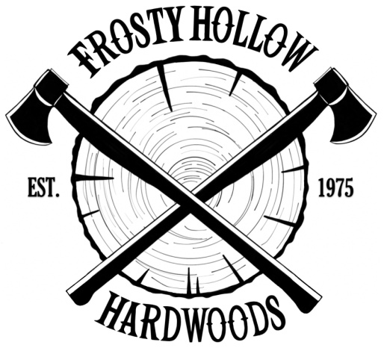
Frosty Hollow Hardwoods
1127 Frosty Hollow Lane
Vandergrift, PA 15690
Phone: (724) 568-3440
Website: https://frostyhollowsawmill.weebly.com/
Hours: Monday - Friday, 8-4, Saturdays and evenings by appointment only

 | Select Grade 4/4 | Rustic Grade 4/4 | Select Grade 8/4
Ash | 3.20 | 1.75
Basswood | 2.50 | 1.50 | 3.50 | 12/4 3.50
Cherry | 2.80 | 1.80 | 3.95
Hickory | 2.85 | 1.85 | 3.85
Hard Maple | 3.25 | 1.50 | 4.25 | Select 5/4 4.25
Soft Maple | 2.95 | 2.00
Red Oak | 2.75 | 1.75 | 3.75
Poplar | 2.50 | 1.50 | 3.25
Walnut | 5.95 | 4.75 | 7.90
Mahogany | 5.75
White Oak | 4.75 | 2.50 | 6.75 | QTR: 5.75  Rift: 5.50
Northeastern Pine |  | 1.75 | 2.00 (knotty)
Aromatic Cedar |  | 4.25
Hemlock | Green 0.95

Please inquire about species and thicknesses not listed. Prices subject to change.

Add 15₵/BF for hit/miss S2S 15/16
Add 35₵/BF for finish S2S 3/4
Add 15₵/BF for SLR 1 edge

